**Lab 1**

Q2. What is the difference between cat and more command?

* **cat**: Show the contents of a file at once.
* **more**: Show the contents of a file one screen at a time, then waits for you to press the spacebar to see more.

Q3. What is the difference between rm and rmdir using man?

* **rm**: Removes files or directories.
* **rmdir**: Removes *empty* directories only

Q4. Create the hierarchy under your home directory:

a. Remove dir11 in one-step. What did you notice? And how did you overcome that?

There is nothing happened because I used **(rm -r dir1/dir11)** instead of

**(rmdir dir1/dir11)**, which deleted empty directories only.

b. Then remove dir12 using rmdir –p command. State what happened to the hierarchy (Note: you are in your home directory).

The hierarchy became has one branch **(docs > mycv)**

c. The output of the command pwd was /home/user. Write the absolute and relative path for the file mycv

The absolute path > **/home/dell/docs/mycv**

The relative path > **docs/mycv**

Q5. Copy the /etc/passwd file to your home directory making its name is mypasswd

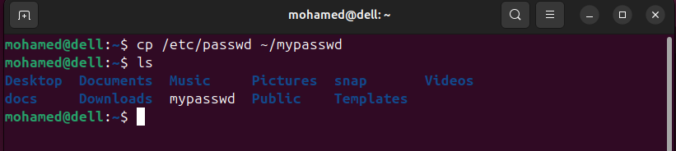

Q6. Rename this new file to be oldpasswd.

Q7. You are in /usr/bin, list four ways to go to your home directory

1. use this command > **cd ~**
2. use this command > **cd**
3. use this command >**cd $HOME**
4. use this command >**cd /home/mohamed** [user_name]

Q9. Display the first 4 lines of /etc/passwd

Q10. Display the last 7 lines of /etc/passwd